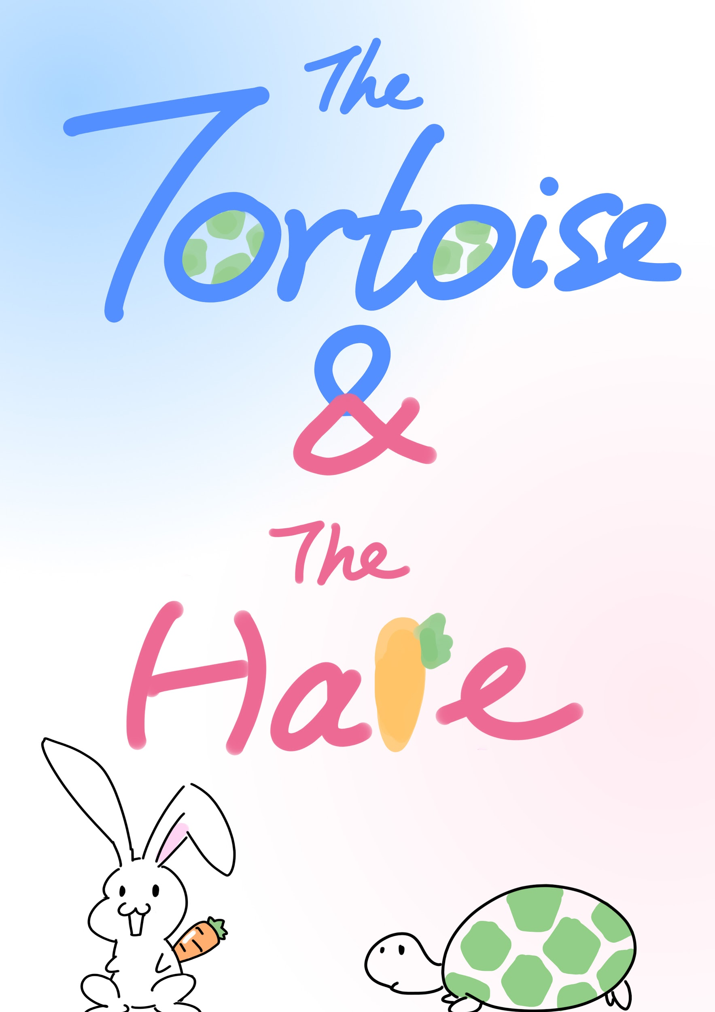

## Components

When you open the box, you will find: 1 x 8D Dice, 1 x Game Board, 1 x Rule Book, 8 x animal figures

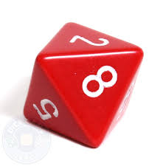

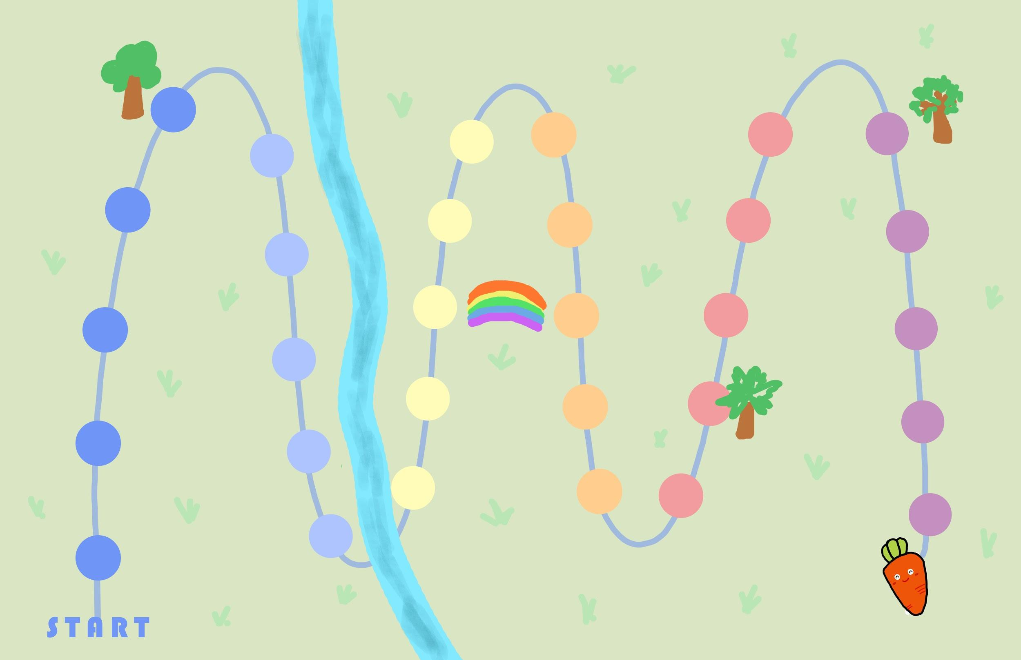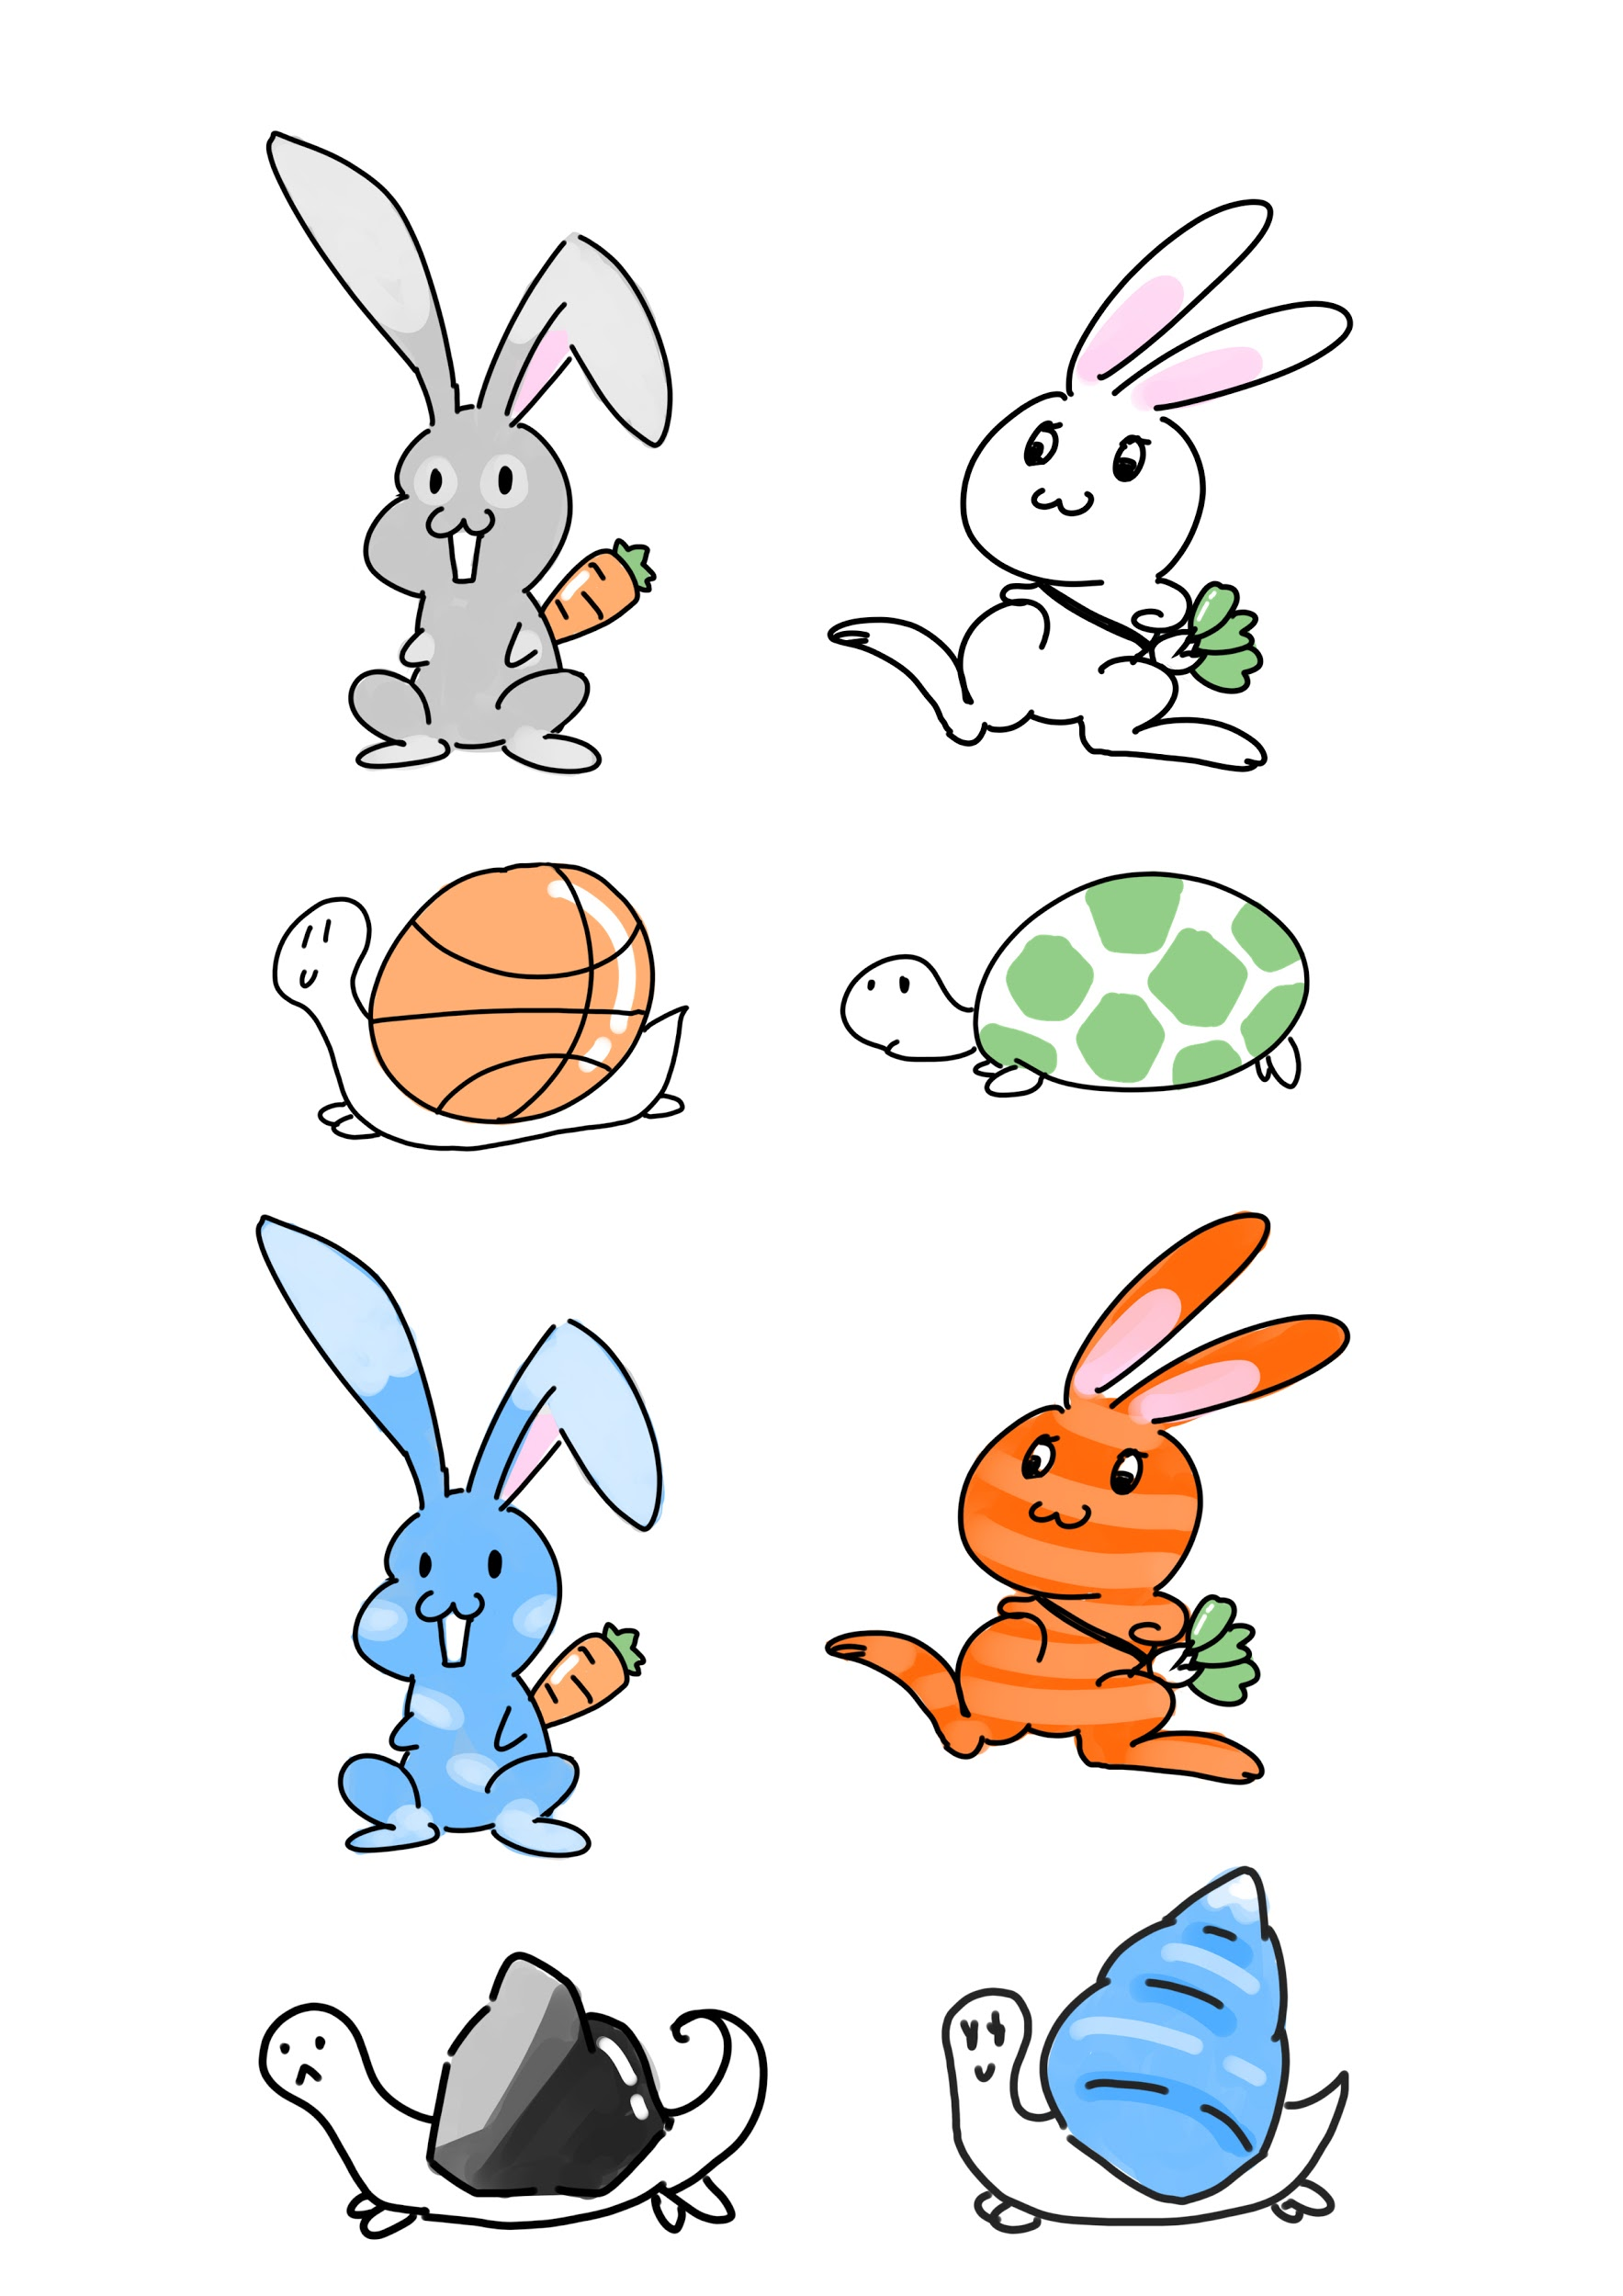

## Objective

The first player who is able to get both his/her hare and tortoise wins the game.

## Setup

Each player has 1 x hare and 1 x tortoise, and both are placed at the starting point at the beginning of the game.



## Rules

### Basic Rules

* At the beginning of your turn, you roll the dice, the number you draw will determine the number of steps you can move forward.
* Choose one of your tokens to move forward.
* If you choose to move the hare, you can move it x units forward, where x is the number you rolled.
* If you choose to move the tortoise, you can move it x/2 (round up) steps forward, where x is the number you rolled.

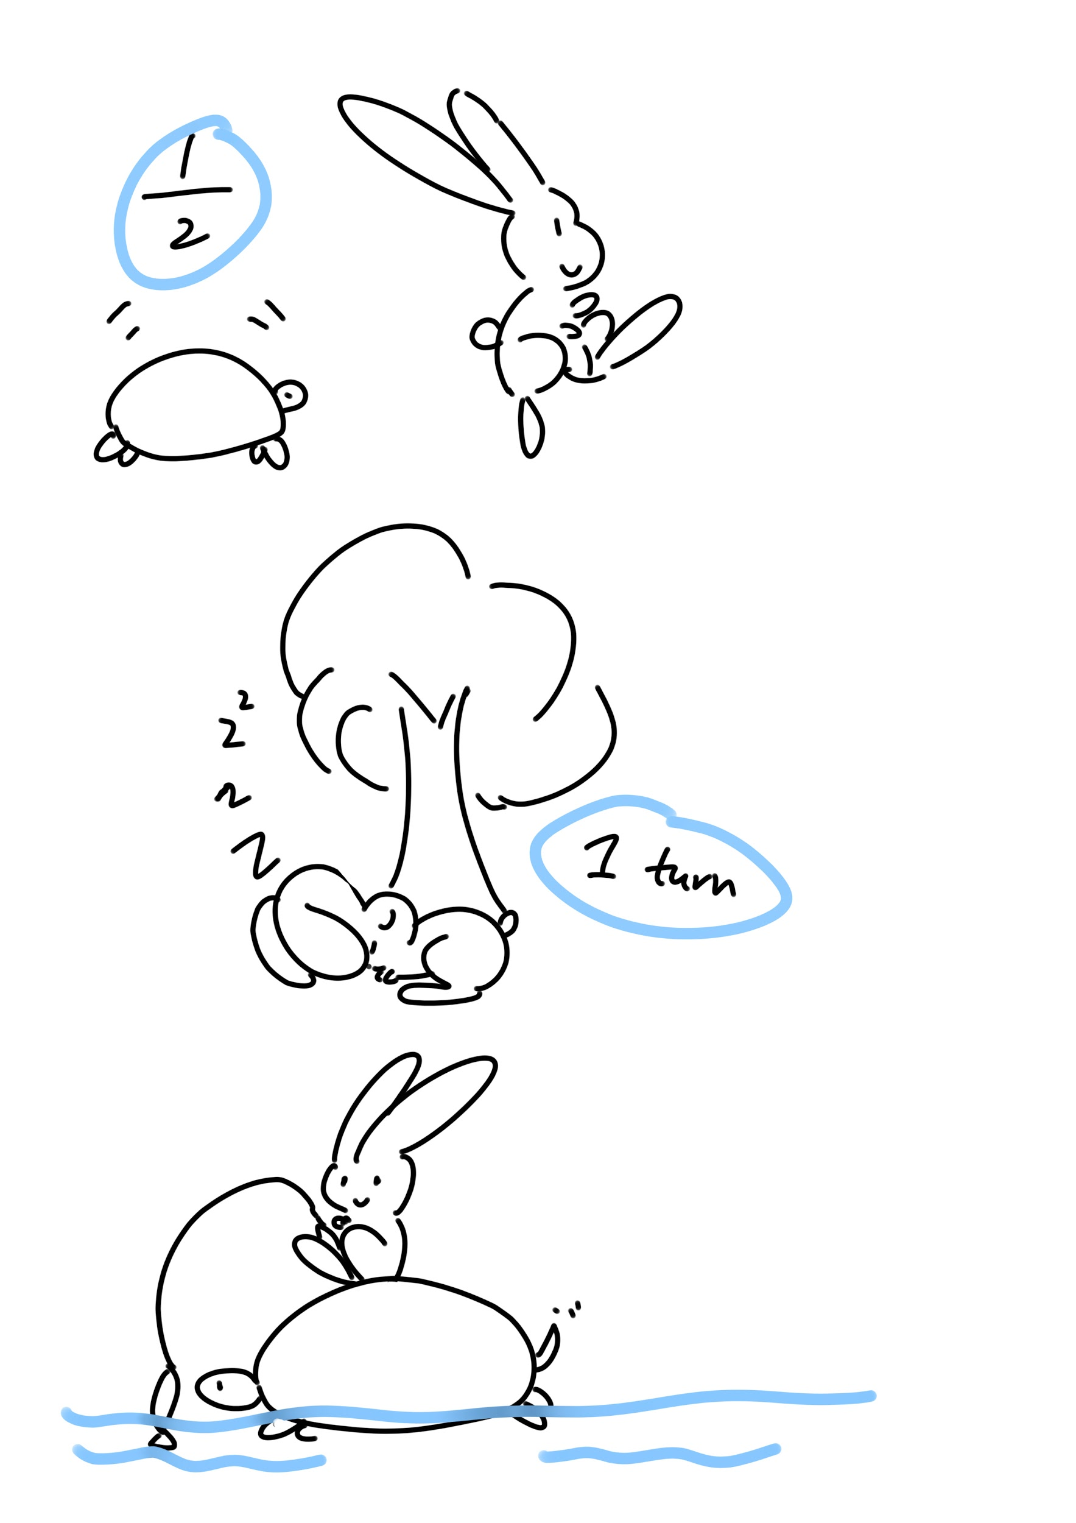

### Special Rules

* If you roll an 8, you have two choices:
  + Swap the position of your hare and your tortoise
  + Swap one of your animal's position with that of one other player's.
* If you choose to swap with another player’s , the two chosen animals have to be of the same type (the hare with the hare, and the tortoise with the tortoise only).

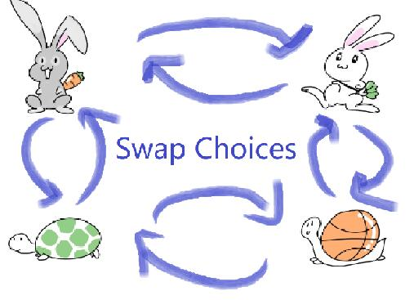

* If any of your tokens reaches the end, your “8” roll will do nothing. Skip your turn.
* If your token moves to a location where there is a token of the same type, you kick the other token back X steps. X = ½ of your steps (round up) that round.
* If the kicked token hits another token of the same type, the token gets hit also moves back X steps, cascading down.

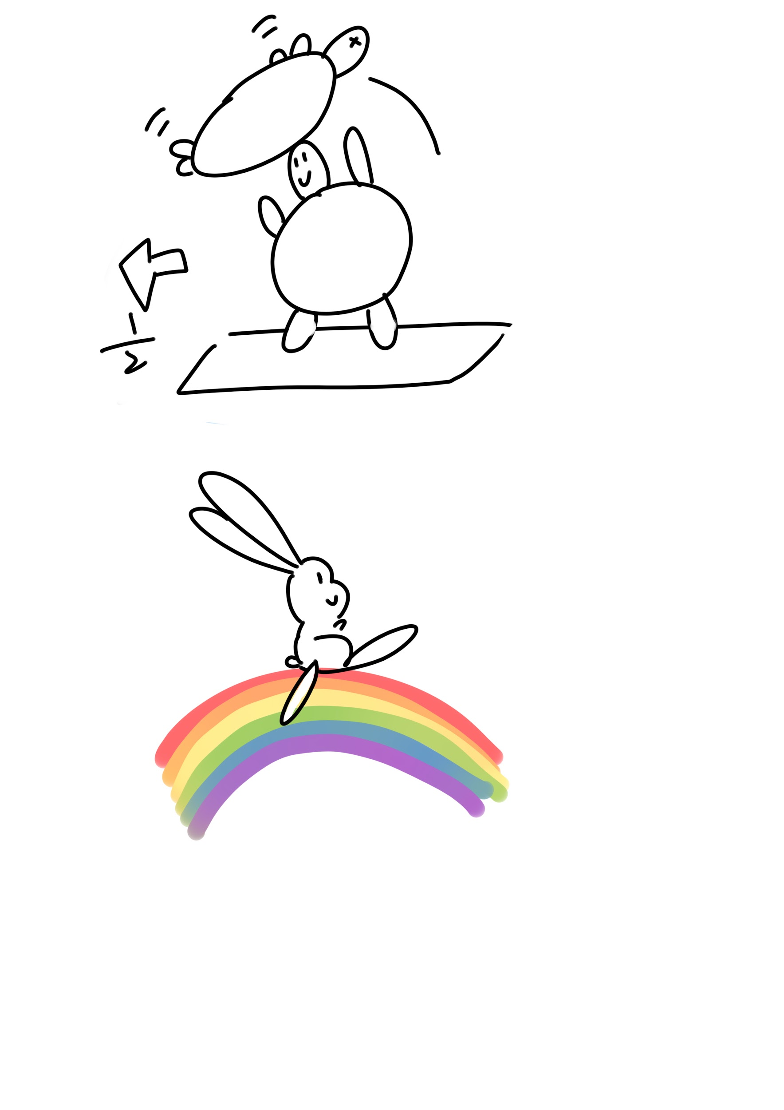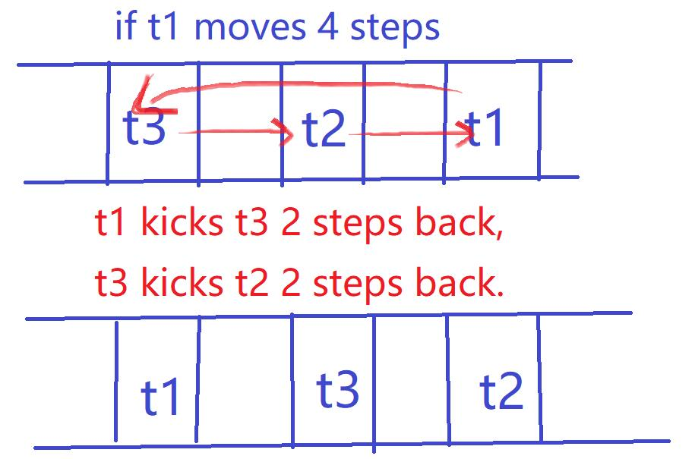

### 

### Special Locations

**Tree:** If you choose to move the hare and the number you draw allows you to move past a tree, your hare has to stop at the tree and it ends this round of your turn



**Rainbow:** If your animal lands directly on the starting location of the rainbow, it can ride the rainbow and jump to the end of it.



**River:** River affects the hare only and divides the map into the east side and the west side. Your hare cannot cross the river from west to east, until your tortoise is on the east side. If your tortoise runs faster than your hare, the river will have the same effect as a tree to your hare, it has to stop at location 11 first and then it can move forward as normal in the next round. Swapping your own tortoise (which is already on the East side) and hare using the 8 number is not affected.

